Komoot Navi Display

Small Bluetooth Low Enegergy (BLE) receiver to display the navigation information from the Komoot app (Android or iPhone).

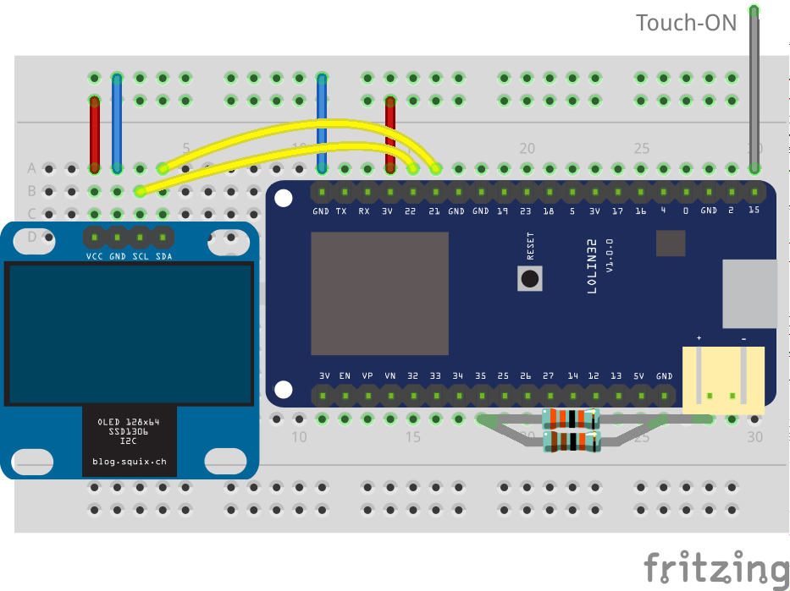
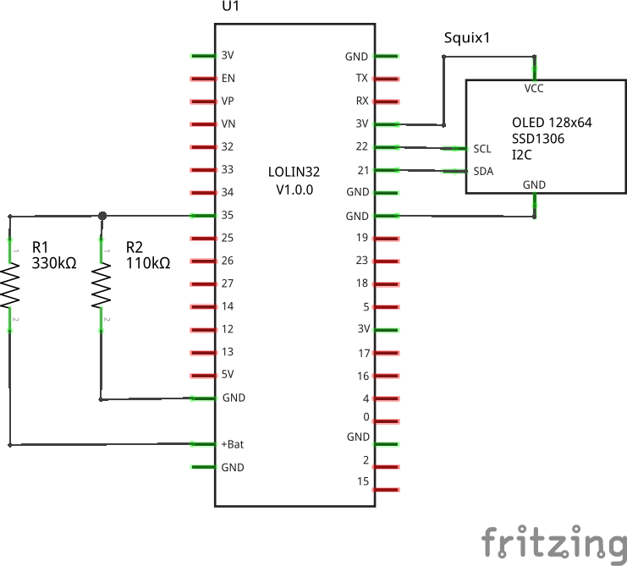
Breadboard wiring: Schematic:

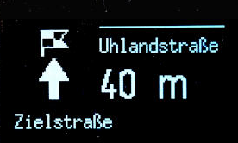

The bar at the top right of the display indicates the remaining power of the LiPO battery.
Below this bar the previous street name is show, which is usually the current street.
At the bottom the name on the street name after the next junction is displayed.

The display orientation can be rotated by the value of the “rotation” variable in the code.

The device automatically enters deep sleep mode if there is no BLE signal or update for more than 30 seconds. It can be switched on by touching pin 15 (default, can be changed in source code).

References
- Komoot BLE specification: https://github.com/komoot/BLEConnect
- Neil Kolban's BLRexample file: https://github.com/nkolban/ESP32_BLE_Arduino
- Adreas Spiess Polar receiver video https://youtu.be/osneajf7Xkg

